Factory Methods
A Factory Method is a method that produces new objects. Factory methods are often used by frameworks and toolkits to create objects that provide access to the framework. Factory methods are also used to provide flexibility in the type of object created.
The Java Calendar class provides a simple factory method. The class designers want to allow for different types of Calendars depending on locale. To create a Calendar use:
Calendar cal = Calendar.getInstance();
In fact, the object created is not an instance of Calendar. It is a GregorianCalendar (a subclass).

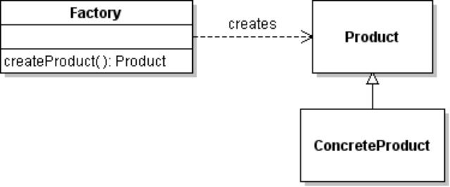
UML for Simple Factory Method
A simple factory method, such as Calendar.getInstance(), has a structure like:

Factory Method Pattern
The Factory Method Pattern is a little more than a simple factory method. In the pattern, the factory method is defined in an interface (or abstract class) and the Product is also an interface.
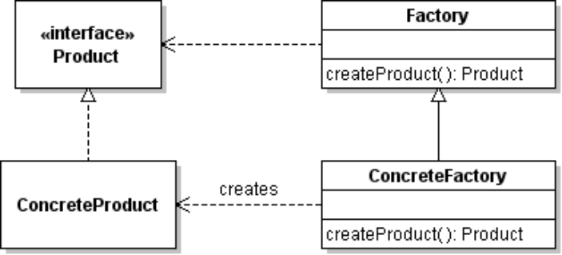

Why Use Factory Methods?
There are several forces that suggest using a factory method. Here are a few:
1. creating objects is complex. A factory method can handle the complexity so the user's code does not have to. Calendar is an example: the Calendar properties need to match the user's locale and time zone.
2. you want to dynamically change the type of object created. A Factory Method can (for example) use run-time configuration data to decide which kind of object to create. For example, an app that uses the Strategy Pattern might use a factory method to get a concrete strategy. In eXceedVote, the strategy might an algorithm for selecting winners, where the actual strategy is selected either via a config file or the admin interface.

Java Media Framework and MP3 Player
The Java Media Framework (JMF) is a framework for handling multimedia, including MP3. To play an MP3 file you must create a Player object. JMF can play different types of media (audio and video), so creating a Player requires knowing the type of media you want to play and the codecs available on your system.
To make it easy for the programmer to create the correct kind of Player, the framework has a factory class named Manager to create Player objects.
import java.net.URL;
import javax.media.*;
...
URL url = new URL("file:///d:/music/somefile.mp3");
Player player = Manager.createRealizedPlayer( url );
player.start();
// later...
player.stop();
A Player may have a visual control panel (that extends java.awt.Component) for use in GUI interface:
Component controlpanel = player.getControlPanelComponent();

Example: Iterable and Iterator
Many kinds of objects create Iterators. The Iterable interface defines a factory method for creating an Iterator. All Collection classes are Iterable. This enables us to write software that uses an iterator without knowing how the Iterator is created or what the actual Iterator class is.
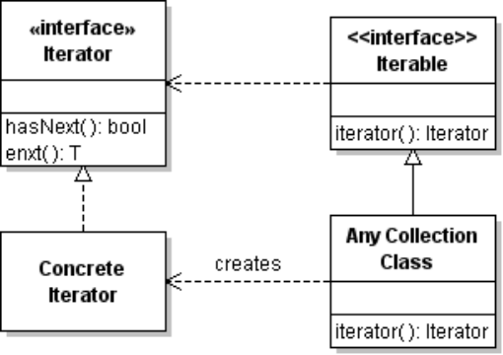
iterator( ) is factory method to create an iterator over the collection.
The actual iterator class is not known, and programmer doesn't need to know
List<String> list = new ArrayList<String>( );
list.add( "dog" );
...
// create an iterator
Iterator<String> iter = list.iterator( );
while ( iter.hasNext() ) System.out.println( iter.next() );
A for-each loop requires an Iterable object as argument. It implicitly creates an Iterator to loop over the elements:
for( String item : list ) System.out.println( item );

Example: MIDI System
The javax.sound.midi package contains classes for controlling the computer's sound system. The sound system provides Synthesizers, Sequencers, and Receivers. To play notes you can use a Synthesizer. But Synthesizer is just an interface. How do you create a concrete Synthesizer object for your hardware?
The MidiSystem class contains several factory methods, including getSynthesizer:
Synthesizer synthesizer = MidiSystem.getSynthesizer();
The Synthesizer interface has its own factory methods for getting Soundbanks and Synthesizer Channels.
synthesizer.open();
Soundbank soundbank = synthesizer.getDefaultSoundbank();
synthesizer.loadAllInstruments( soundbank );
// get a channel so we can play notes
MidiChannel channel = synthesizer.getChannels()[0];
Play a note using numbers 0 - 127. Middle C is note 60.
channel.noteOn( 60, 200 ); // 200 is "velocity" of the note.
We can use the MidiSystem without knowing any concrete classes that the objects belong to. This is possible because of factory methods and interfaces describe a general Midi system.
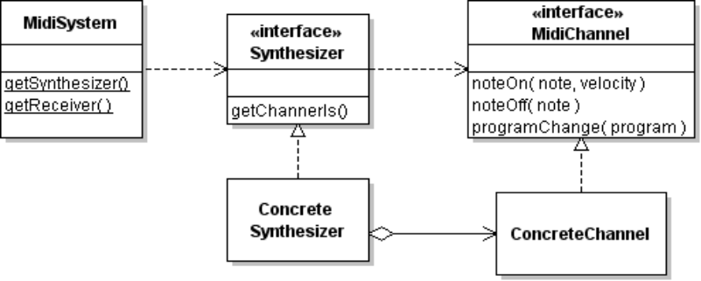
MidiSystem contains many factory methods. It creates MidiDevice objects and Mdi Sequences using a file or URL.

Example: Logging and slf4j
slf4j is a Logging framework that adapts other Logging frameworks. To create a Logger object in a particular class, you write:
Logger logger = LoggerFactory.getLogger( MyClass.class ):
logger.warn( "this is a warning message" );
logger.info(
"this Logger is really a " + logger.getClass().getName() );
slf4j can use the JDK java.util.logging classes, the well-known Log4J logger, "simple" logging that prints to System.out, or "No-op" logging (does nothing) as the underlying logging program. The choice depends on which JAR file you include in your project: if you include slf4j-simple.jar it uses simple logging, if you include slf4j-log4j12.jar it uses Log4J, etc. The LoggerFactory makes the decision at run-time based on what if find on the classpath.

How to Dynamically "Program" a Factory?
To write a factory that can change the kind of objects it creates at runtime without changing the Java code, there are several common techniques:
1. Register a concrete factory with the abstract factory class. The abstract factory chooses among available concrete factories when an object is requested.
2. Dynamically load a factory class using configuration information from a properties file.
3. Use the ServiceLoader class (JDK 6 and above) to locate available service provider classes (classes that implement a "service" interface). The ServiceLoader class uses information from JAR files (in the META-INF/services directory) to locate available service provider classes. The JDBC drivers use this mechanism.
Example:
Suppose we have an interface named Factory. We also have an AbstractFactory class with a static method named getInstance( ) that returns a concrete Factory object:
Factory myfactory = AbstractFactory.getInstance( );
We can change the actual type of the object returned by getInstance( ) by having AbstractFactory read the name of the actual factory class (at runtime) and create a new object of this factory class.
How does AbstractFactory get the name of the concrete factory to create? One way is to use a property, either a system property or your own properties file. You can choose any property name (being careful to avoid names of existing system properties). Let's use the property name factory.name.
We can create a load the new Factory class at run-time and create an object by using code like this:
public abstract class AbstractFactory {
public static Factory getInstance() {
String factoryclass =
System.getProperty( "factory.name" );
//TODO this may throw many exceptions. Catch them.
Factory factory =
(Factory) Class.forName(factoryclass).newInstance( );
return factory;
}
What is not shown above is code to catch exceptions, and there should be a "default" factory class to use in case the factory.name property is not set or can't be used.
Concrete Example: In this example we use a "simple factory" for Grader objects, to reduce the amount of code, but the technique is the same.
We have a Grader that assigns grades ("A"-"F" or "I") using an array of scores. Since there are many possible grading algorithms, Grader is an interface for a concrete Grader:
public interface Grader {
public String grade( int[] scores );
}
The instructor changes his grading algorithm every semester, and to avoid modifying his grader app he uses a factory method to create a grader:
public class GraderFactory {
public static final String PROPERTY = "grader.class";

/** Get a concrete instance of grader. */
public static Grader getGrader() {
String classname = System.getProperty(PROPERTY);
Grader grader = null;
try {
grader = (Grader) Class.forName(classname).newInstance();
} catch (Exception ex) {
System.err.println("No grader configured");
return defaultGrader();
}
return grader;
}
/** Default grader assigns "I" to everyone. */
private static Grader defaultGrader() {
return new Grader() {
public String getGrade(int[] scores) { return "I"; }
};
}
}
To test the code, try this:
public class GraderTest {
public static void main(String[] args) {
Grader grader = GraderFactory.getGrader();
int[] scores = { 75, 80, 91, 80, 83, 87 };
String grade = grader.grade( scores );
System.out.println("Your grade is " + grade);
}
}
Because there is no Grader yet, it used the default grader and prints "Your grade is I".
Now, we'll write a grader so students either get an "A" (average 85 and up) or an "F":
package ku.grading;
public class StrictGrader implements Grader {
public String grade(int[] scores) {
double average = 0;
for (int score : scores) average += score;
if (average != 0) average = average/scores.length;
if (average >= 85.0) return "A";
return "F";
}
}
Assuming all classes are on the class path, run it from a Windows command shell using:
cmd> java -Dgrader.class=ku.grading.StrictGrader GraderTest
Your grade is A.

